Linux Commands Practice Questions -2

File and Directory Operations
- How do you copy a file named "report.pdf" from your home directory to a folder called "documents"?
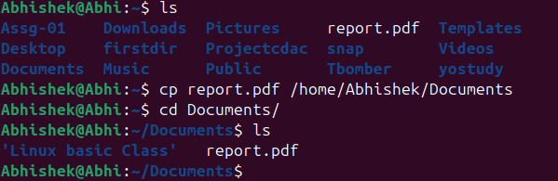
- What is the difference between rmdir and rm -rf commands?
rm | rm-r
It is used to remove empty directories | It is used to remove directories that are in a recursive of files
This is used to delete specific files | It is used to delete an empty directory and its content
Ex: it is used to remove an empty directory | Ex: it is used to remove old project directories
Syntax: rm text_info.txt | Syntax: rm -r old_dbda_proj

- How do you move a file named "data.csv" from the "downloads" folder to the "projects" folder?
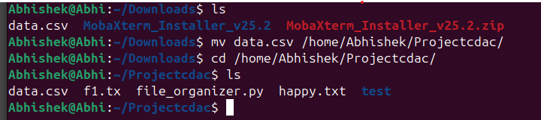
- What command shows your current location in the file system?
By using the command “PWD”, which stands for Print Working Directory

- How do you create three empty files named "log1.txt", "log2.txt", and "log3.txt" simultaneously?
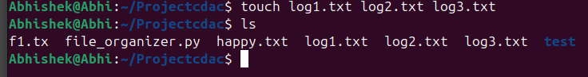
- How do you change a directory name from "old_project" to "new_project"?
By using “mv old_project new_project”, we can change the name of a directory. To perform this task, we need to be present in the directory where the old_project is stored

- How do you delete a file named "temp.log" without any confirmation prompt?
By using the “rm temp.log”, we can remove the following file without any confirmation prompt.

- Display your current directory path using a command.
By using the command “PWD”, which stands for Print Working Directory

- Show directory contents with file sizes in human-readable format (KB, MB, GB).
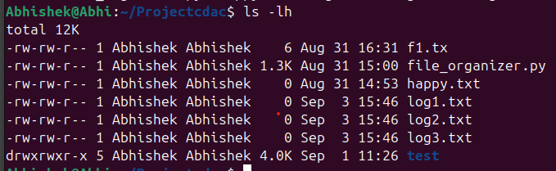
- Explain the meaning of the first character in file permissions (d, -, l) when using ls -l.
“d” stands for directory, and the “-“ hyphen stands for empty/nothing, “l” stands for link it might be a hardlink or a softlink.
- List all files including those starting with a dot (.) in the "/etc" directory.
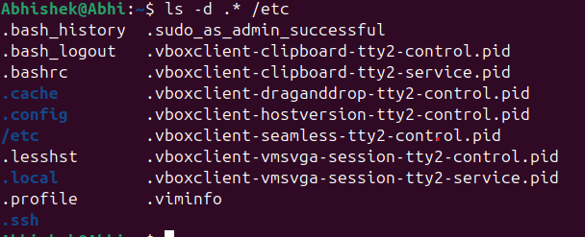
- Show only files that start with a dot in your home directory.
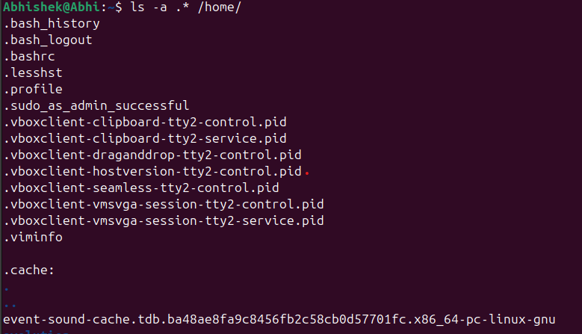
- Create a directory structure "workspace/projects/web/frontend" in a single command.

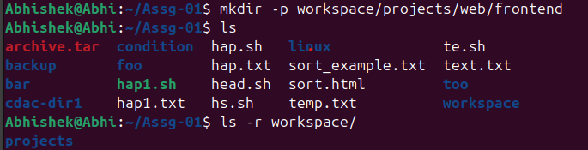
- Create the following nested structure in one command:
company/
├── departments/
│ ├── hr/
│ ├── finance/
│ └── tech/
└── employees/
├── active/ └── former/
- Create a directory named "test_dir", then remove it and verify it's gone.
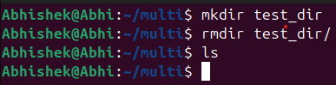

File Content and Text Processing
- Save the manual page of the find command to a file named "find_manual.txt".
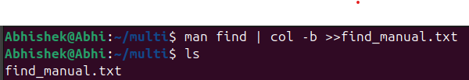
- Display the first 15 lines and last 8 lines of "find_manual.txt".
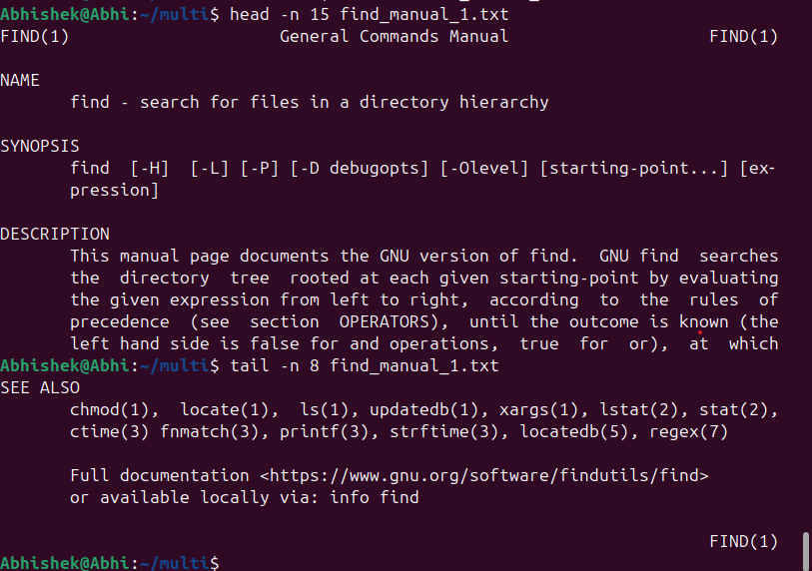
- Copy "find_manual.txt" to a folder named "manuals" and rename the copy to "find_help.txt".
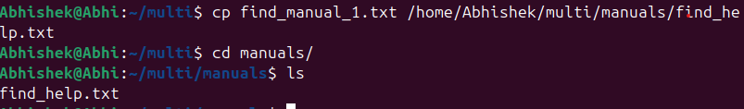
- Count the total lines, words, and characters in "find_manual.txt".
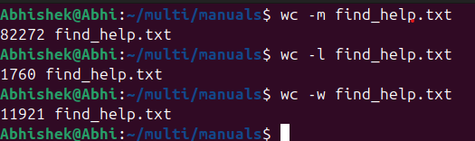
- Show your last 15 executed commands.
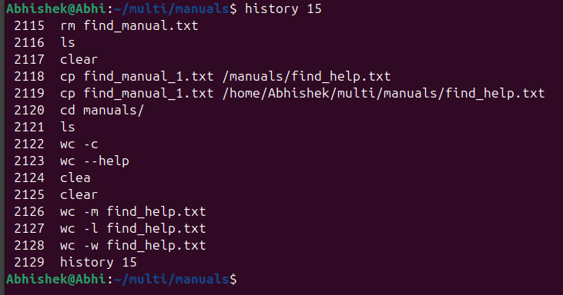
- Create a tar.gz archive of your home directory's Documents folder.
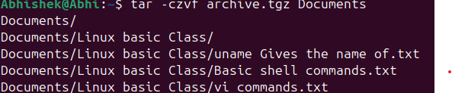
- Create a zip archive of your Desktop folder and list its contents without extracting.
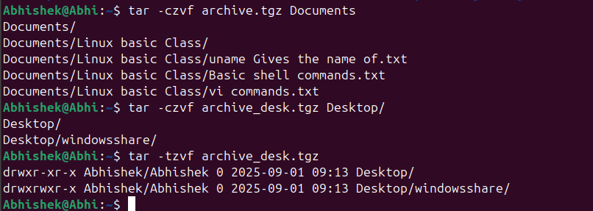

- Set permissions for "script.sh" to be readable, writable, and executable by owner only.
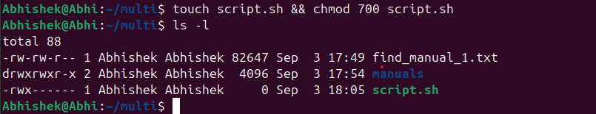
- Change the owner of "database.txt" to user "admin".
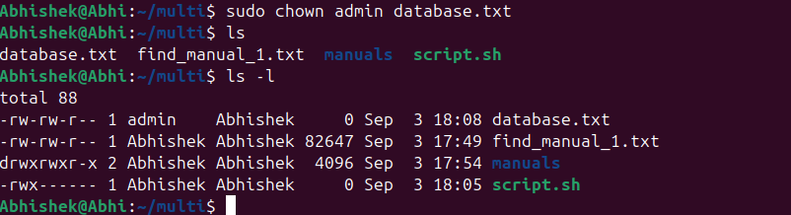
- Display currently running processes in your terminal, all system processes, and sort processes by CPU usage.
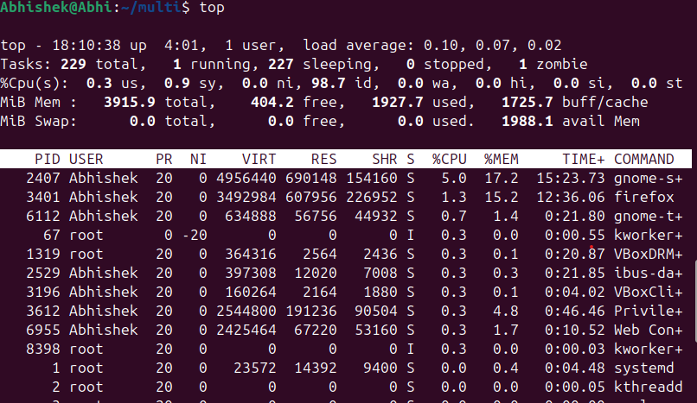
- Show the current date/time and display the calendar for the current month.
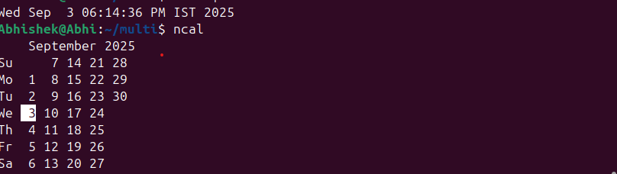
- Set the system date to January 15th, 2025, 2:30 PM.

System Information Commands
- Research and explain these commands: uptime, df, du, free.
Uptime is used to tell how long the system has been running. It gives the current time, how long the system has been running, how many users are currently logged on, and the system load averages for the past 1, 5, and 15 minutes
Df – report file system space usage. Df displays the amount of space available on the file system containing each file name argument. If no file name is given, the space available on all currently mounted file systems is shown.
Du – estimate file space usage. Summarize device usage of the set of files, recursively for directories.
Free – displays the amount of free and used memory in the system. Free displays the total amount of free and used physical and swap memory in the system, as well as the buffers and caches used by the kernel.

- Create a directory "linux_lab", navigate into it, create "permissions_test.txt", check its default permissions, modify umask to 022, create "new_permissions_test.txt", and compare their permissions.
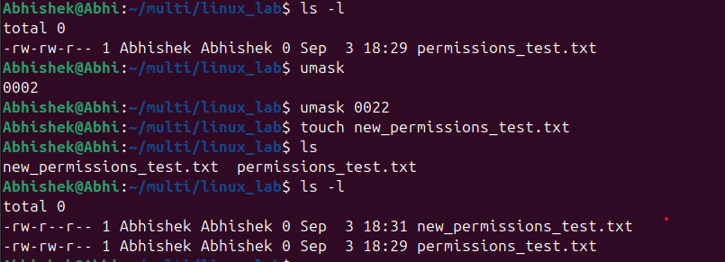

- Create "original.txt" and make a hard link named "hard_copy.txt" pointing to it.
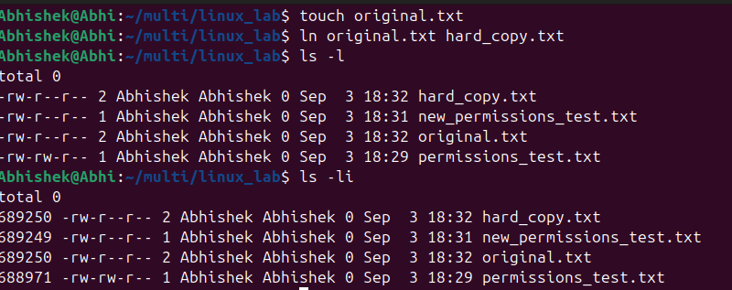
- Create "source.txt" and make a symbolic link named "sym_link.txt" pointing to it.
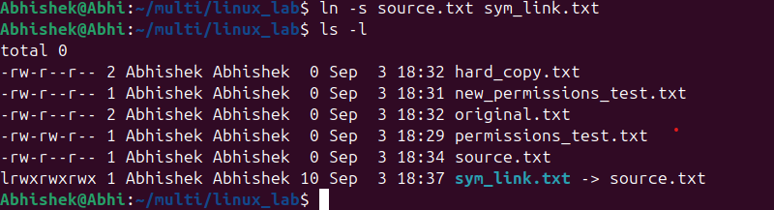
- Copy the entire "projects" directory from a remote server to your local "Downloads" folder using SCP.
- Download files from a public FTP server like ftp.gnu.org using command line FTP client.
- How do you remove a directory named "old_data" containing files and subdirectories?
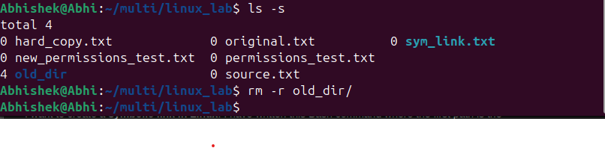
- List all files in "/var/log" showing detailed information including hidden files.
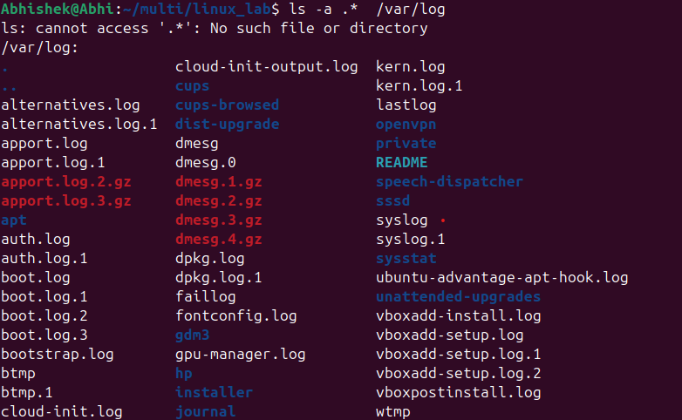
- Create a file named "config.txt" in the path "/opt/myapp/config/" using the command line.

- Search for the word "error" in all ".log" files within the current directory and subdirectories.
- Create a directory "myproject" with permissions 755 (rwxr-xr-x).
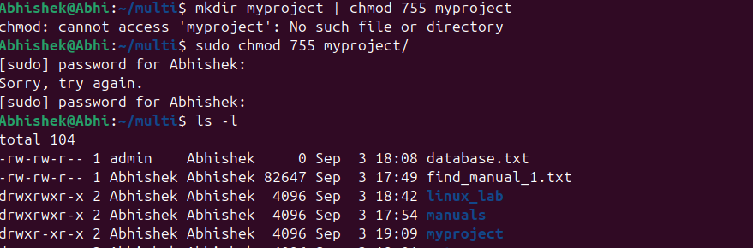
- Create a compressed tar archive named "backup.tar.gz" containing all files and subdirectories in "/home/user/documents".
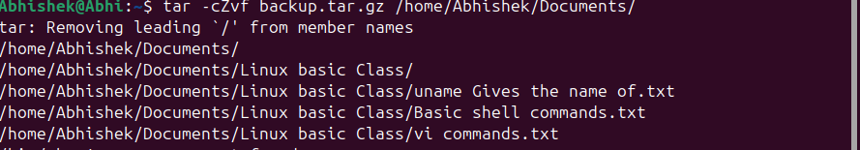
- Give read and write permissions to owner and group, but only read permission to others for "shared.txt".
- Find the size of "video.mp4" and display it in human-readable format (MB/GB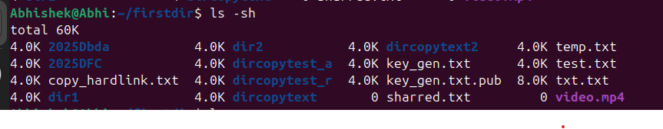
- Find all files in "/home" and subdirectories that were modified in the last 7 days.
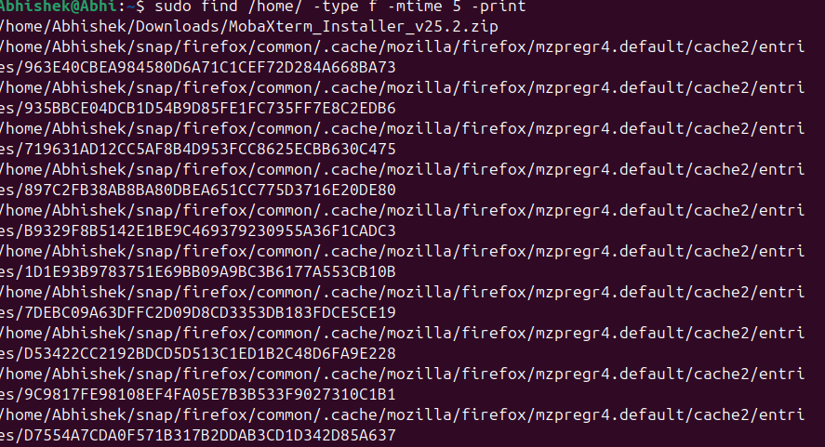
- Compare "version1.txt" and "version2.txt" and show only the differences.
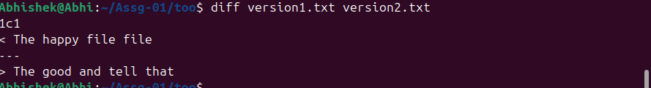
- Synchronize "/home/user/photos" with "/backup/photos" preserving all file attributes.
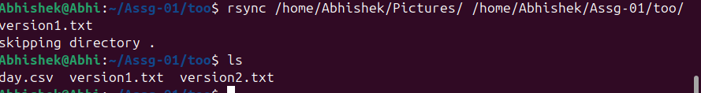
- Extract characters 10-25 from each line in "data.txt".
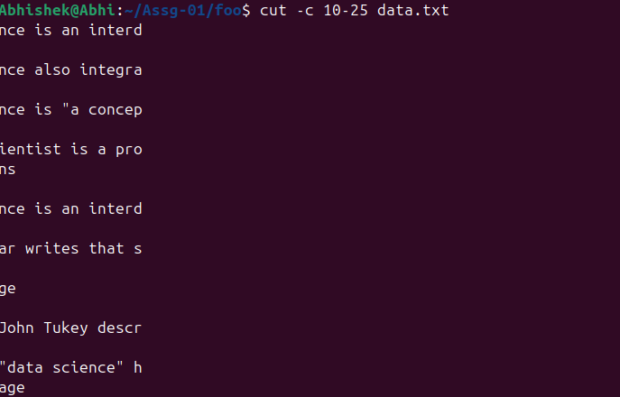

- Extract only the file "readme.txt" from "archive.tar.gz" without extracting the entire archive.

- Count how many times the word "function" appears in "script.js".

Advanced Questions
- How do you monitor real-time changes to a log file named "application.log"?

- How do you find all files larger than 100MB in your entire file system?
By using the command “ find /home/ -type f -size 100MB+ “, this will check the entire file system
- How do you create a file with specific content using command line without opening an editor?
By using the echo command that is “echo ‘The number is’> f1.txt”
In the code, we have used echo and the greater-than symbol to assign the statement to f1.txt
- How do you compress a directory using gzip and preserve the original?
Code is tar – cvzf archive.tar.gz /home/user/dir1/
- How do you find all files owned by user "john" in the "/home" directory?
By using the path “/home/john/” I can retrieve all the files which are stored under the user john
- How do you schedule a command to run every day at 9 AM using cron?

- How do you check disk usage of the current directory and sort by size?
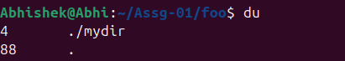
- How do you find and kill a process by name?
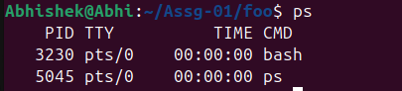
By using the PID number, we can kill the process command is “kill PID”
- How do you create a symbolic link that points to a directory instead of a file?
By using the command “ln -s /home/jake/dir1 /home/jake/dir2

- How do you find all executable files in your PATH?
By using the command “find /home/Abhishek/Documents/ -type f -name *.exe”
This will give u all the executable files

- How do you merge two sorted files into one sorted file?
By using the command “sort -m file1.txt file2.txt > merged.txt,” this will return the merged file
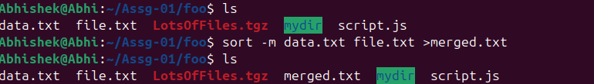
- How do you display only unique lines from a file that contains duplicates?
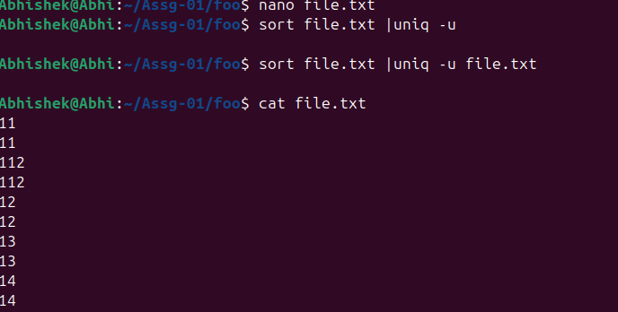
- How do you monitor system resource usage in real-time?
By using the “top” command, we can track the real-time system usage
- How do you find files that are exactly 0 bytes (empty files)?
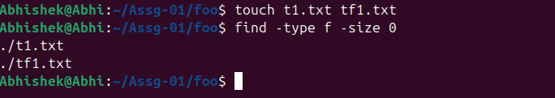
- How do you change file timestamps without modifying content?
By using the “touch”, it will only access the time of a file to the current system time and modify the time of a file to the current system time.
- How do you create a file that can only be read by the owner and no one else?
By using the “chmod 400 “ command, which will make the file or directory read-only mode for the owner and - - to the group and others.
- How do you find broken symbolic links in a directory?\
To find the broken symbolic link of a directory, we need to use the command “find /home/ -xtype l”. This will search for the file that has a broken link
- How do you copy files while preserving their original timestamps?
By using the command” cp -p /home/user/Documents/filee.txt /home/usre/downloads”, this command will preserve all the information and permissions of that file
- How do you display the last 50 lines of a log file and continue monitoring new additions?
By using the command “ tail -n 50 -f /home/dir1/tset.log”, this will only return only the last 50 lines of data sorted in the log file

